Lab No. 07

1. Import Related Python Libraries
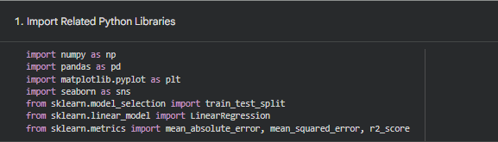
2. Acquire the Targeted Dataset
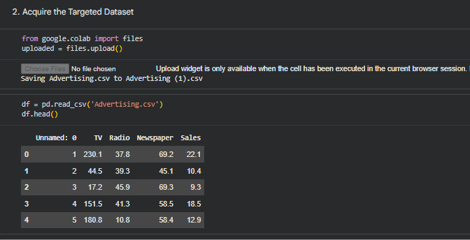
3. Check Dataset Compatibility with Linear Regression
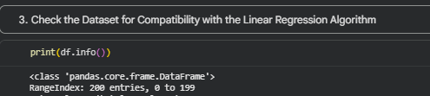
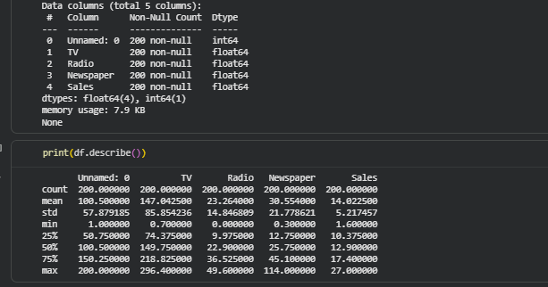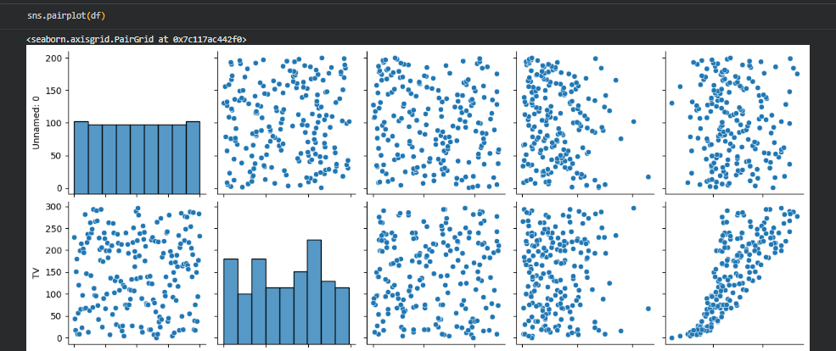
4. Identify Independent and Dependent Variables
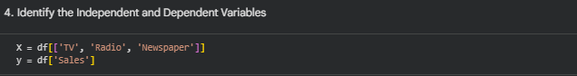
5. Perform Exploratory Data Analysis
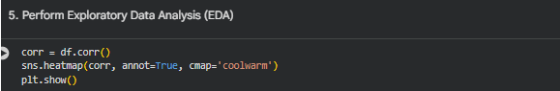
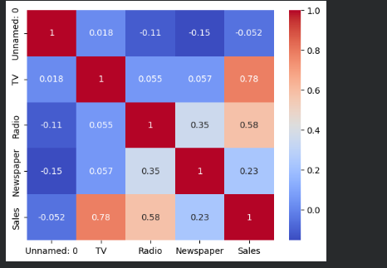
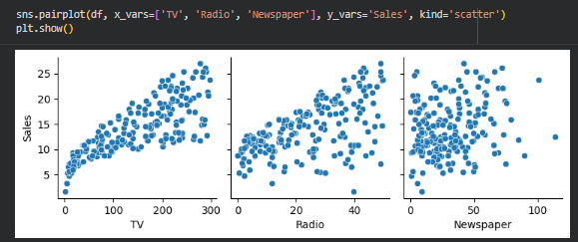
6. Perform Data Preprocessing
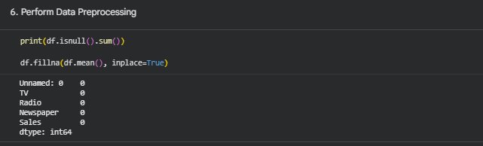

7. Create Model Building and Model Validation Dataset
8. Check Training and Testing Dataset Compatibility
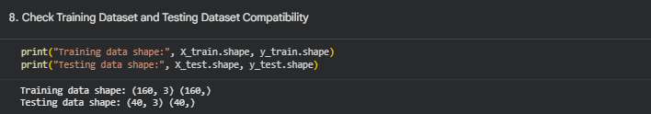
9. Import Linear Regression Algorithm
10. Instantiate Linear Regression Model
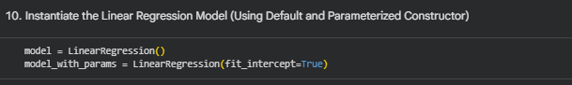
11. Train the Algorithm
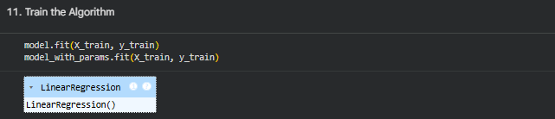
12. Predict Target Value Using Unseen Data
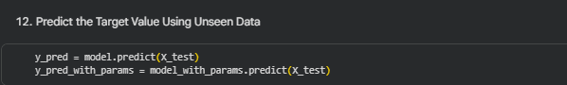

14. Evaluate Model Performance Using MAE, MSE, and RMSE
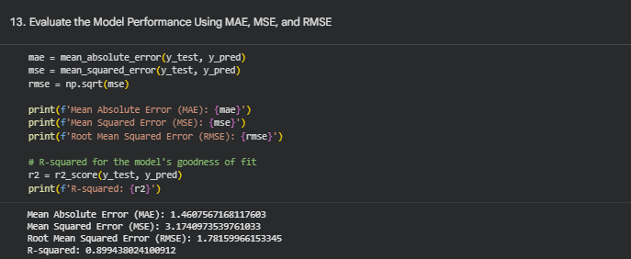

Lab Task

Multivariate Linear Regression Model from Scratch
